Quinn Hawkins, Robert Sullivan

Project 1 Write-up

The 10-ks for Moderna and Tesla both came from factset, under the filings/document search tab. The 10ks were in a standardized format, with the sections all following a similar naming scheme. Special care had to be taken to remove ‘ from the headings, as they were not supported in the strings used for splitting the documents. We pulled sections 7 and 7a from the 10-ks, as they were the relevant parts of the management discussion. In order to increase the accuracy of the analysis, we removed all tables from sections 7 and 7a manually, as doing it algorithmically wouldn't be worth it for the 4 10-ks we were focusing on.

The earnings call files were downloaded as pdfs from Factset and then converted to text files with online apis before insertion into the data folder of the project. The earnings calls are separated into two sections, the first containing the prepared remarks and other administrative info for the call, and the second containing the questions and answers. Once the data cleaning was performed, we were left with 2 separate dataframes. The prepared remarks dataframe was consists of 3 columns (person, title, text). The questions and answers dataframe consists of 4 columns (person, title, type, text).

TSLA stopwords metrics

cosine similarity: [[0.95833488]]

jaccard similarity: 0.3954154727793696

edit distance: 2380, edit distance normalized: 0.75772047118752

---------------------------------------------------------------------------

TSLA no stopwords metrics

cosine similarity: [[0.77030562]]

jaccard similarity: 0.3807957908582703

edit distance: 2301, edit distance normalized: 0.7566589937520553

---------------------------------------------------------------------------

TSLA tfidf stopwords metrics

cosine similarity: [[0.95833488]]

jaccard similarity: 0.3954154727793696

edit distance: 3073, edit distance normalized: 0.9783508436803565

---------------------------------------------------------------------------

TSLA tfidf no stopwords metrics

cosine similarity: [[0.77030562]]

jaccard similarity: 0.3807957908582703

edit distance: 2974, edit distance normalized: 0.977967773758632

---------------------------------------------------------------------------

MRNA stopwords metrics

cosine similarity: [[0.99109233]]

jaccard similarity: 0.654747225647349

edit distance: 969, edit distance normalized: 0.5974106041923551

---------------------------------------------------------------------------

MRNA no stopwords metrics

cosine similarity: [[0.94851186]]

jaccard similarity: 0.6426250812215725

edit distance: 899, edit distance normalized: 0.5841455490578298

---------------------------------------------------------------------------

MRNA tfidf stopwords metrics

cosine similarity: [[0.99109233]]

jaccard similarity: 0.654747225647349

edit distance: 1454, edit distance normalized: 0.8964241676942046

---------------------------------------------------------------------------

MRNA tfidf no stopwords metrics

cosine similarity: [[0.94851186]]

jaccard similarity: 0.6426250812215725

edit distance: 1375, edit distance normalized: 0.8934372969460689

---------------------------------------------------------------------------

For this analysis, we can break down the analysis into a few sections: cosine similarity, jaccard similarity and edit distance. For a refresher, the cosine similarity measures the similarity between the word vectors that comprise the document. The jaccard similarity measures the distance between two pieces of text. The edit distance determines the amount of editing needed in order to make the text identical. These metrics, when viewed in the context of different sections of text, can inform a practitioner about the nature of differences between different documents. For this analysis, we will mostly be focusing on the metrics that involve no stopwords, as stopwords add noise to the data that is unnecessary, and make disparate pieces of data appear more similar than they actually are.

For Tesla, we can see that the jaccard similarity, cosine similarity and the edit distance all indicate the texts are very different. This makes sense, because of the nature of Tesla. Tesla is a very volatile, nuanced company that has many different facets to its business, meaning there are a lot of opportunities for management to introduce differences between the different discussions.

Compared to Tesla, Moderna has much more similar 10k discussions. The cosine similarity between the two 10-ks for Moderna, both with and without stopwords, are higher than the cosine similarities for Tesla. The edit distance is also lower by a significant margin, indicating less disparities between the Moderna 10-ks. This could be viewed as a reflection of the more rigid standards of the biotech industry, as management may be more hesitant to “rock the boat” than the management of Tesla.

Between both pairs of 10-ks, it can be seen that stop words have a significant effect on the similarity measures. Stop words are words that are irrelevant to the analysis of the meaning of the text. They can be viewed as statistical noise that doesn't matter much in the interpretation of the results. Keeping in common stop words raises the similarity between the documents, as there are more shared words in between the documents. TF-IDF (term frequency, inverse document frequency) weighs the importance of words within the entire document in the context of the document. Based on the TF-IDF analysis, we can see that the Tesla 10-ks are not only different just in their verbiage, but also in the meaning of the documents, as the TF-IDF similarities are lower than those for Moderna.

1. Earnings Calls Stats

Moderna:

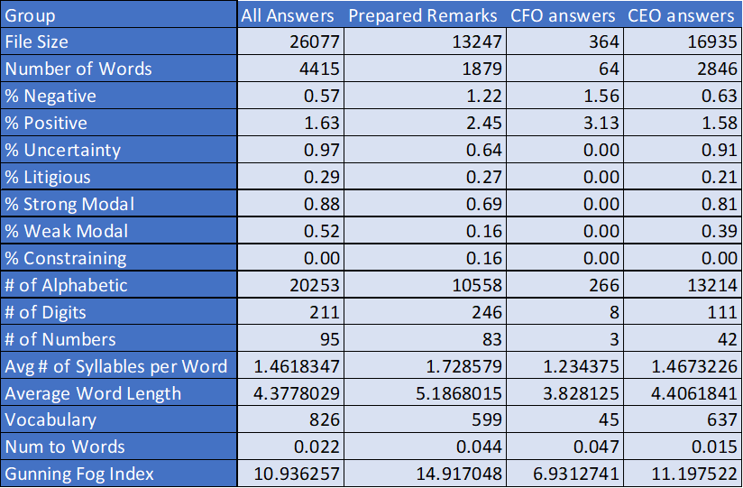

Tesla:

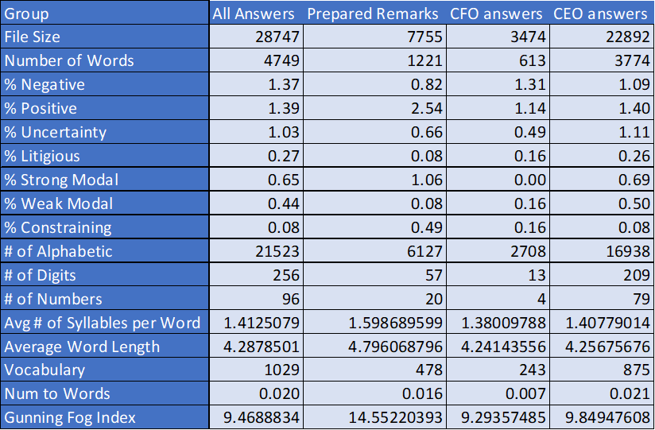

1. Complexity, clarity vs evasiveness and ambiguity

The Gunning Fog Index for all Moderna answers given during the earnings call ~ 11. When the data is reduced to the Moderna CFO only the index drops to ~ 7 and the CEO is 11.2. The S&P 500 had an average language complexity score of 12.36. A low GFI score is indicative of management that isn't attempting to obfuscate information about the company’s position, as management of companies that have something to hide often try to distract the audience by using complexity. The low GFI score is a bullish signal for investors, as it indicated the company isn't attempting to hide anything. Tesla has an even lower GFI score across all sections compared to Moderna, which is indicative of low evasiveness, and is a bullish signal just like it was for Moderna.

1. Tone: confidence vs uncertainty

The uncertainty percentage of words for all Tesla answers (1.03) was slightly higher than that of Moderna (.97). This implies that the management of Tesla was more hesitant to solidify their statements than the management of Moderna. This could imply that Tesla is hesitating to bring up bad news that could negatively reflect on the company. In addition the Stong modal percent for Moderna was .88 percent whereas for Tesla it was only .65 percent indicating further than Tesla was more unsure of their future performance than Moderna.

1. Concreteness: Use of numbers vs words

While for the earnings call questions and answers section Moderna and Tesla had comparable stats for concreteness of speech. The one surprising discrepancy was in the prepared remarks where Moderna had a concreteness score of almost three times that of Tesla indicating that they may have stronger financial or otherwise results to share. This may play into Tesla’s worries about cybertruck sales that are heavily referenced in the negative sentiment section upcoming.

1. Sentiment – Positivity/Negativity. What are the topics management is positive or negative about?

For Tesla the most positively talked about topics in the Questions and answers sections was the ramping up of efforts to control cost and increase efficiency in their production process.

The most negative topics for Tesla are as follows. The most negative sentiment came front he discussion of the difficulties of manufacturing the cybertruck. The other negative topics included the discussion of troubles with ramping up production in factories, two sections discussing the difficulties consumers are having with affording Tesla cars, and a discussion on how macroeconomic factors like interest rates could negatively affect the company.

For Moderna, the negative sentiment concentrates around their ability to file for approval for their products quickly and to be able to deploy their current product by 2025. This indicates that they may be facing issues with the approval process and are worried about not being able to hit deadlines. The most positive discussion for Moderna is centered around the discussion of an ongoing clinical trial as well as the commercial market in which they are selling.

The overall positive percent for Moderna was 1.6 and for Tesla it was only 1.39 indicating that Moderna had better results that they were more confidant in presenting to the audience at the earnings call.

1. Compare the prepared remarks to the Q&A

For Tesla, the prepared remarks had a significantly higher gunning fog index when compared to the Q&A section. Moderna follows this trend, as both companies have similar numbers.

1. Compare the CEO comments to the CFO comments

The CFOs for both companies spoke much less than the CEOs, which can be viewed as normal, as the CEO is the public facing head of the company. The CFOs of both companies had significantly more negative words in their answers than the CEOs or the prepared remarks, which may be a negative signal as the CFOs often have insider information that they unconsciously manifest in their speech.

1. Examine 10-k changes and determine what changes are relevant to investors:

Tesla:

Two of the most important changes between the 10-ks is in the section discussing the macroeconomic conditions affecting Tesla and the section describing sensitivity to interest rates:

Macro conditions

2021 10-k

due to the covid pandemic, there has been uncertainty and disruption in the global economy and financial markets.

2022 10-k

unexpected changes in business conditions, materials pricing, including inflation of raw material costs, labor issues, wars, trade policies, natural disasters, health epidemics such as the global covid pandemic, trade and shipping disruptions, port congestions and other factors beyond our or our suppliers’ control could also affect these suppliers’ ability to deliver components to us or to remain solvent and operational.

Discussion of sensitivity to interest rate changes:

2021 10-k

interest rate risk we are exposed to interest rate risk on our borrowings that bear interest at floating rates.

2022 10-k

our ability to make scheduled payments of the principal and interest on our indebtedness when due, to make payments upon conversion or repurchase demands with respect to our convertible senior notes or to refinance our indebtedness as we may need or desire, depends on our future performance, which is subject to economic, financial, competitive and other factors beyond our control.

In conjunction with the increased discussion of macroeconomic risks, the much more verbose discussion of macroeconomic conditions could be viewed as Tesla being fearful about their future in an economy where the cost of credit is higher, as they are a growth company that requires interest rates to remain low.

Moderna:

Moderna has some differences between the 10-ks when discussing taxes. This is important, because tax strategy can have a large effect on the overall profitability of a company and its attractiveness to investors:

2021 10-k

we develop our assessment of uncertain tax positions and as additional information becomes available, estimates are revised and refined.

2022 10-k

we evaluate uncertain tax positions on a quarterly basis and consider various factors, that include, but are not limited to, changes in tax law, the measurement of tax positions taken or expected to be taken in tax returns, the effective settlement of matters subject to audit, information obtained during in process audit activities and changes in facts or circumstances related to a tax position.

The more verbose discussion of tax positions in the 2022 10-k elucidates that Moderna may be more concerned about their tax situation when compared to a year before, which is relevant news for traders/investors who may share the same concern.

This assessment has revealed a few key findings. The first finding is that the management of Tesla and Moderna both follow similar trends. The CEO’s words for both companies were overwhelmingly more positive in aggregate when compared to the CFO’s responses. In addition, the prepared remarks for both companies had much higher GFIs when compared to the Q&A sections, indicating a deliberate push from company management to obfuscate their statements. In terms of the 10-ks, we noticed that the managements wording often remained identical in inconsequential sections, while in important sections often whole sentences would be changed.

There are a few significant limitations of the analysis that we were not able to overcome for this project. The first issue is that of a small sample size. Because we only gathered information on two equities, and that information for each equity was made up of only 2 10-ks and 1 earning call, there is a lack of concrete data on which to analyze trends. We also struggle to discover which data is representative of the ecosystem as a whole because of the small sample size, as it is difficult to assemble a representative sample using the information we had available. Another limitation that we ran into was the inability to consistently parse out items such as tables from the 10-ks, which necessitated manual removal. This led to some inconsistencies in the parsing of the 10-ks, and would not be feasible for a larger sample.

We learned a few things about the documents that weren't immediately apparent from a cursory analysis. We learned that although the 10-ks are discrete documents that change as the company changes, there are still many places where it is apparent management just copies from the previous period. This was made apparent during our side by side analysis of the documents, where there were many large sections that were identical between the two documents. Another part of the 10-ks

Based on the information gathered above, we are making the decision to go long on Moderna and neutral Tesla. Moderna has a higher strong modality, more positive verbiage and less negative verbiage when compared to Tesla. Many other factors appear comparable in the 10-ks, Moderna has more consistent language between the 10-ks and that is a strong indicator of a company facing less issues requiring them to update their verbiage. If the literature regarding natural language processing of company filings and earnings calls are to be considered relevant, Moderna appears to be the much stronger investment of the two.

**Citations**

“Analyzing Sentiment in Quarterly Earnings Calls - Q4 2022.” *Analyzing Sentiment in Quarterly*

*Earnings Calls - Q4 2022 | S&P Global Market Intelligence*, 22 Dec. 2022,

[www.spglobal.com/marketintelligence/en/news-insights/blog/analyzing-sentiment-in-quar](http://www.spglobal.com/marketintelligence/en/news-insights/blog/analyzing-sentiment-in-quar)

terly-earnings-calls-q4-2022.

ChaGPT for the HTML function

<https://chat.openai.com/share/0802edd9-820c-40ad-aeec-523d1a84eec7>